# Install Meta mask

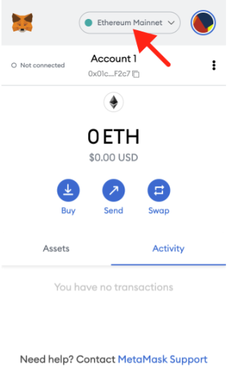

# Make a rinkeby faucet

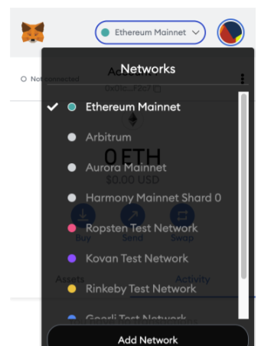

# Add account number here

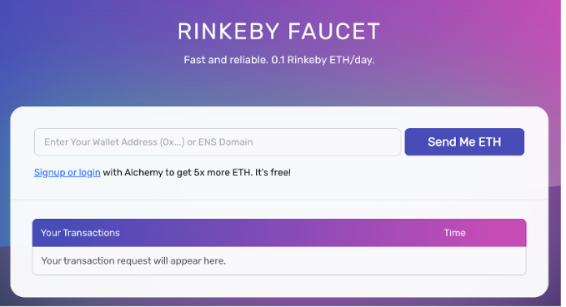

0x7042857058E0E7Cd2fE555976eb87B72ce301a6b

# Receive eth

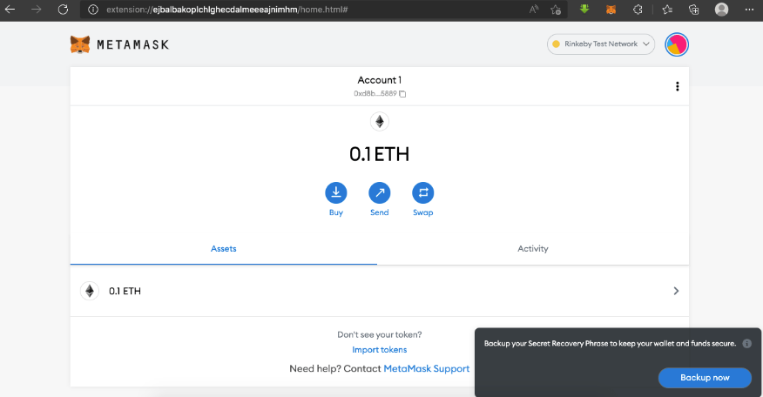

# Run nft contracts

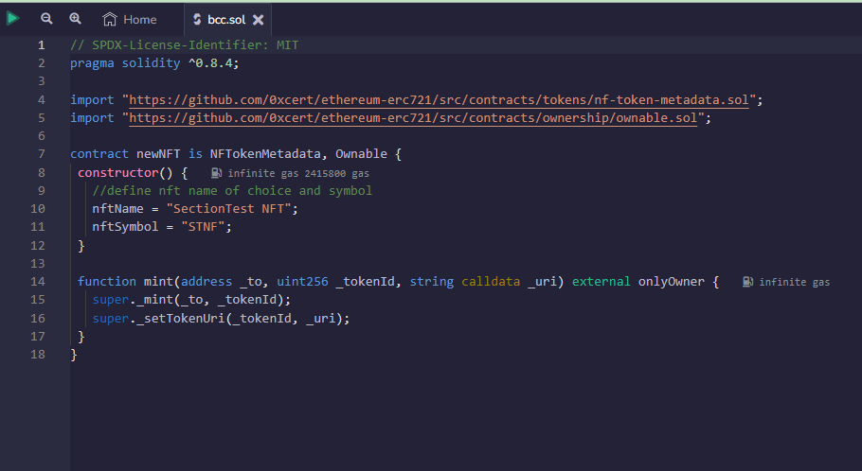

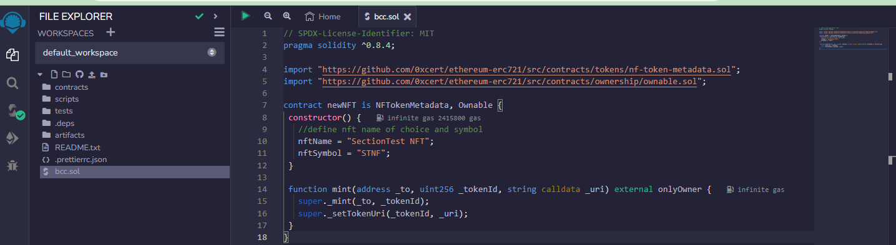

// SPDX-License-Identifier: MIT

pragma solidity ^0.8.4;

import "https://github.com/0xcert/ethereum-erc721/src/contracts/tokens/nf-token-metadata.sol";

import "https://github.com/0xcert/ethereum-erc721/src/contracts/ownership/ownable.sol";

contract newNFT is NFTokenMetadata, Ownable {

 constructor() {

   //define nft name of choice and symbol

   nftName = "SectionTest NFT";

   nftSymbol = "STNF";

 }

 function mint(address _to, uint256 _tokenId, string calldata _uri) external onlyOwner {

   super._mint(_to, _tokenId);

   super._setTokenUri(_tokenId, _uri);

 }

.

}

# Send to new test account

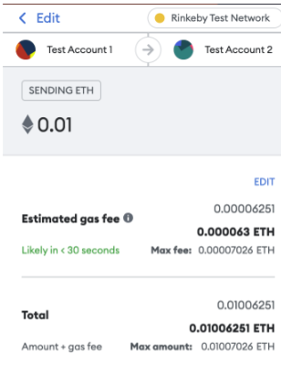

# Insert the url and approve then make transaction

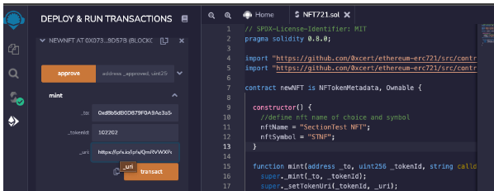

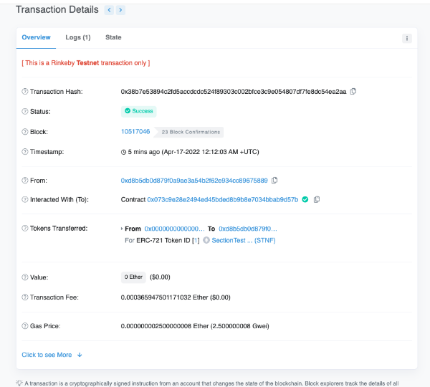

# Install IPFS Desktop for open sea

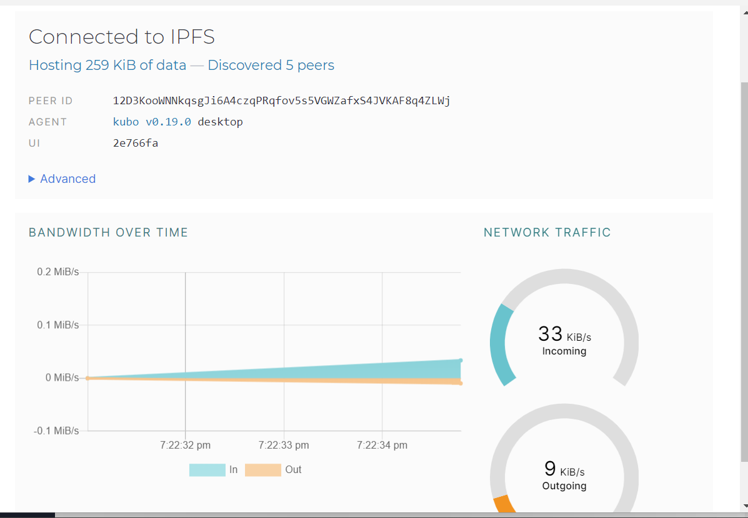

# Add image to make nft

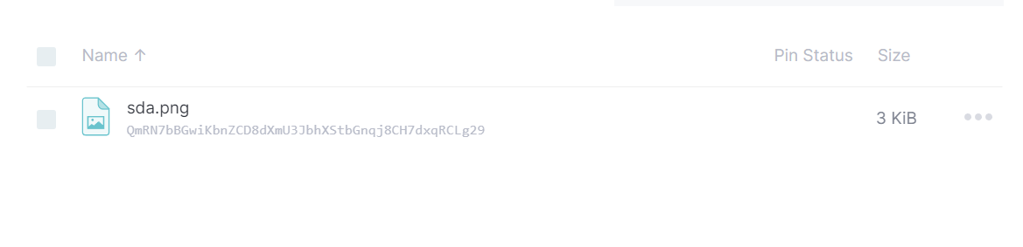

# Image will be up as nft for sale

